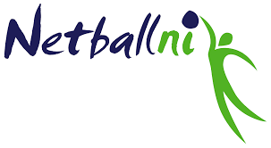

CONFIRMATION OF FITNESS TEST RESULT

Please complete this form electronically and return to HeadOfWorkforce@netballni.org

Umpire’s details
Name of Umpire
Test details and results
Date of Test
Level reached
State any relevant conditions
Tester’s details
Name of Tester
Contact details Email
Tel/Mob
Accreditation - give details of body that has accredited you to administer this test

This is to certify that I have tested the above umpire and I can confirm the following:
- Test used was Multi-Stage Fitness Test (Beep/Bleep/20m Shuttle Run Test)
- All specifications for the administration of this test were correctly applied
- The umpire reached the level indicated on the above date
- I am officially accredited to administer this test

If you are unable to scan this form and do not have an electronic signature, placing your name below will be deemed to be certification of the above information.

Signed:

A copy of this form should be forwarded to headofworkforce@netballni.org within 14 days of the test

