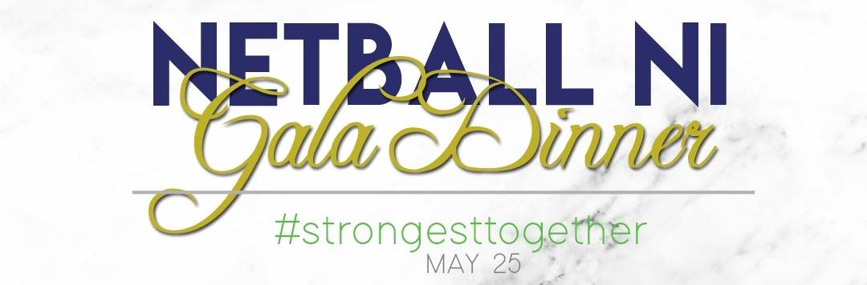

Ticket Order Form

Name of Club:
Lead contact:
Contact telephone number:
Number of tickets required |  | tickets at £40 per ticket
Please note U18s are welcome to attend but will not be served at the bar and must have a nominated adult present on the night responsible for them
Total amount payable | £
Payment method (please tick) | BACS | Cash | Cheque
Please note any dietary requirements

All tickets purchased before 1st May will receive a free entry into the Netball NI raffle to be drawn on the night

Please return completed form and payment to Netball NI – bookingsandadmin@netballni.org

For office use
Date payment received | Date tickets issued

